Nome del corso MODELLISTICA PER LA MODA - ABPR21

A.A. 2020/2021

Prof. FRANCESCA TACCONI

Data | Orario lezione |  | ore
 | mattina | pomeriggio
02/03/2021 |  | 14:30/19:30 | 5
09/03/2021 |  | 14:30/19:30 | 5
16/03/2021 |  | 14:30/19:30 | 5
23/03/2021 |  | 14:30/19:30 | 5
30/03/2021 |  | 14:30/19:30 | 5
13/04/2021 |  | 14:30/19:30 | 5
20/04/2021 |  | 14:30/19:30 | 5
27/04/2021 |  | 14:30/19:30 | 5
04/05/2021 |  | 14:30/19:30 | 5
11/05/2021 |  | 14:30/19:30 | 5
18/05/2021 |  | 14:30/19:30 | 5
25/05/2021 |  | 14:30/19:30 | 5
Totale monte ore |  |  | 60

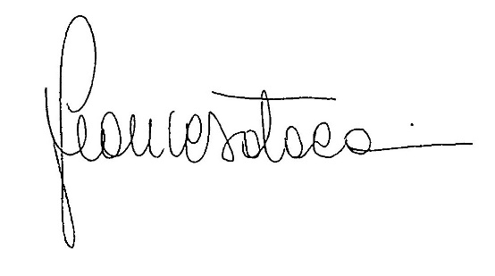
Data 28/02/2021

Firma

