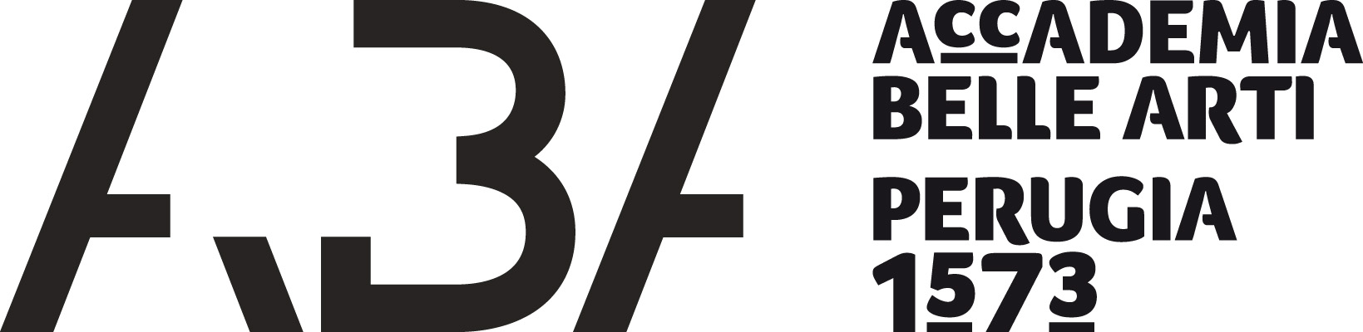

INFORMATION SHEET
INSTITUTIONAL INFORMATION
Name of the Institution | Accademia di Belle Arti “P. Vannucci” di Perugia
Address | P.zza San Francesco al Prato. N. 5, 06123 Perugia
Country | Italy
Erasmus code | I PERUGIA04
Eche | 29257–LA –1–2014-1-IT-E4AKA1-ECHE
website | www.abaperugia.org
Head of the Institution | Avv. Mario Rampini (President)
Erasmus Institutional Coordinator | Avv. Domenico Ferrera  Email: direttoreamministrativo@abaperugia.org  Tl: +39 075 5730631
Erasmus coordinator | Prof. Elisabetta Furin  email. e.furin@abaperugia.org  Tl: +39 075 5730631
Erasmus office head | Dott. ssa Orietta Taschini  Email: erasmus@abaperugia.org  Tl: +39 075 5730631

ACADEMIC CALENDAR 2023-24
First (Autumn) semester:
from 06.11.2023 to 16.02.2024
Winter session exams: | from 19.02.2024 to 01.03.2024
Second (Spring) semester: | from 11.03.2024 to 14.06.2024
Summer session exams: | from 24.06.2024 to 10.07.2024

Public Holidays
All Saints: 01.11.2023
Feast of the Immaculate conception: 08.12.2023
Christmas holidays: from 23.12.2023 to 07.01.2024
Feast of the Patron Saint: 29.01.2024
Easter holidays: from 28.03.2024 to 02.04.2024
Anniversary of the Liberation: 25.04.2024 (26.04.2024 day off)
Labour Day: 01.05.2024

The application deadlines for Erasmus students interested in studying at the Academy of Fine Arts “P. Vannucci” of Perugia are:
1st June 2023 (for the whole Academic Year and the Autumn Semester);
1st December 2023 (for the Spring Semester).
The procedure foresees a nomination letter sent by email by the Sending Institution and signed by the Institutional Erasmus Coordinator.
This letter has to include the full names and surnames of the selected Erasmus students, their email addresses, the School/Department they are enrolled in and has to be sent to the following addresses:
direttoreamministrativo@abaperugia.org
erasmus@abaperugia.org
The student will receive an email of acceptance within three weeks.
Once the student has been accepted, he/she has to fill in an Application Form (http://www.abaperugia.com/upload/allegato-1-211.pdf) and send it to our Erasmus office to the following email address: erasmus@abaperugia.org
Upon his/her arrival, the student will have two-weeks time to update, if necessary, the learning agreement.
For the list of classes, codes and credits, please check the “plans of studies” available at the following link:

https://www.abaperugia.com/piani-di-studio/

Erasmus incoming students are given the possibility to choose either the first level and the second level courses regardless of the departments they belong to or the academic year they are enrolled to.

HELP FOR ACCOMMODATION
Incoming students who need help in finding an accommodation can contact our erasmus office:
Dott. Orietta Taschini Email: erasmus@abaperugia.org.

LANGUAGE REQUIREMENTS
Incoming students
At the Academy of Fine Arts of Perugia the language used for all classes is Italian and therefore we recommend all incoming students to master at least a B1 level of the Italian language.

Incoming teaching/non-teaching staff
For teaching and non-teaching staff the recommended level is Italian or English B1/B2.

ADDITIONAL INFORMATION
The Italian grading system is based on a maximum of 30 points with 18 as the lowest passing grade. 30 “cum laude” may also be awarded.
Grading system
ECTS grade | Grading percentage | Grading percentage  % | Institutional grade
A | 10 | 6.46 | 30L
B | 25 | 20.31 | 30
C | 30 | 17.54 | 28-29
D | 25 | 38.46 | 24-27
E | 10 | 17.23 | 18-23

VISA
Our Institution will provide assistance, when required, in securing visas for incoming and outgoing students/staff, according to the requirements of the Erasmus Charter for Higher Education. Information and assistance can be provided by our erasmus office: Dott. Orietta Taschini Email: erasmus@abaperugia.org

INSURANCE
Our Institution will provide assistance in obtaining insurance for incoming and outgoing students/staff according to the requirements of the Erasmus Charter for Higher Education. Information and assistance can be provided by our erasmus office: Dott. Orietta Taschini Email: erasmus@abaperugia.org

